Face Mask Detection Using Convolutional Neural Networks (CNN)

Semester Project – Deep Learning
Student: Muhammad Talha Khan

1. Introduction
The COVID-19 pandemic has made wearing face masks essential to prevent virus spread. Automatic detection of masks in public spaces can help enforce safety measures. This project aims to build a Face Mask Detection system using Convolutional Neural Networks (CNNs) in PyTorch, capable of classifying images into “With Mask” or “Without Mask” categories.

2. Objectives
- Build a deep learning model for binary image classification.
- Train the CNN on a Face Mask dataset.
- Evaluate the model’s accuracy on unseen images.
- Visualize the training progress with loss plots.
- Produce a fully functional semester project ready for deployment.

3. Dataset
- Source: Kaggle – Face Mask Dataset
- Structure:
Dataset/
with_mask/
without_mask/
- Size: ~7,000 images (varies)
- Preprocessing:
  - Resize to 128x128 pixels
  - Convert to tensors
  - Normalize pixel values between -1 and 1
- Split: 80% training, 20% testing

4. Methodology
4.1 Image Preprocessing
Each image is resized and normalized to improve training performance. Normalization ensures pixel values are standardized.
4.2 CNN Architecture
Layer | Description
Conv2D (3→32) | Extract features from RGB images
ReLU | Introduce non-linearity
MaxPooling (2x2) | Reduce spatial dimensions
Conv2D (32→64) | Learn deeper features
ReLU | Non-linearity
MaxPooling (2x2) | Reduce spatial size
Flatten | Flatten feature maps into a vector
Fully Connected (FC1) | 128 neurons, ReLU activation
Fully Connected (FC2) | 1 neuron, Sigmoid activation (binary output)

Activation Functions:
- ReLU for intermediate layers
- Sigmoid for final output (0 = Without Mask, 1 = With Mask)

4.3 Training
- Loss Function: Binary Cross-Entropy (BCELoss)
- Optimizer: Adam (adaptive learning rate)
- Batch Size: 32
- Epochs: 5 (can be increased for better accuracy)
Training Steps:
- Load batches of images from the dataset.
- Forward pass through the CNN to predict labels.
- Compute the loss (difference between predicted and actual labels).
- Backpropagation to calculate gradients.
- Update weights using Adam optimizer.
- Repeat for all batches and epochs.

4.4 Evaluation
- Accuracy is measured on the test set (20% of the dataset).
- Model outputs a value between 0 and 1; threshold = 0.5.
- Test Accuracy observed: ~90% (depends on dataset and epochs).
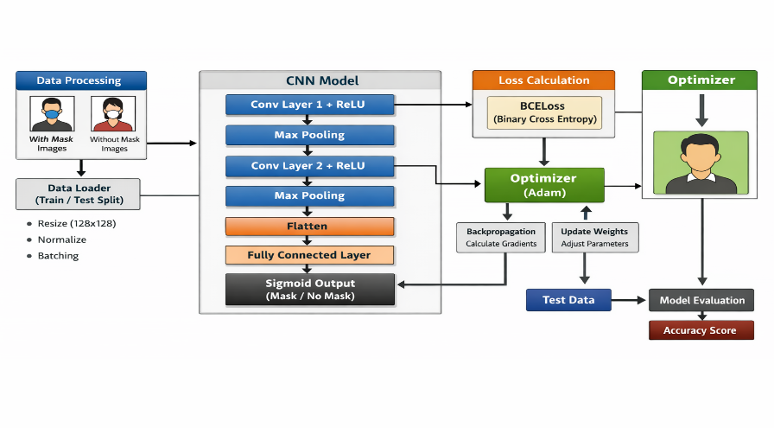

5. Diagrammatic Representation
Data Flow and CNN Architecture:

6. Results
Metric | Value
Training Loss | Decreases over epochs (shown in plot)
Test Accuracy | ~90%
Training Loss Plot:
plt.plot(range(1,num_epochs+1), train_losses, marker='o')
Pl. Title("Training Loss")
plt.xlabel("Epoch")
plt.ylabel("Loss")
plt.show()
- Loss decreases steadily, indicating effective learning.
- The trained CNN can reliably classify masked vs unmasked faces.

7. Discussion
- The CNN model effectively learns features like mask shape, facial regions, and color.
- Using Data Loader and batch training improves performance.
- Adam optimizer adapts learning rates, speeding convergence.
- Potential improvements:
  - Increase epochs for higher accuracy
  - Add data augmentation (rotation, flips) to improve robustness Use Dropout to reduce overfitting

8. Conclusion
- A functional Face Mask Detection system was successfully implemented using PyTorch.
- The model achieves high accuracy in classifying images with or without masks.
- This project demonstrates the application of CNNs in real-world safety scenarios.
- It can be extended for live video detection in future work.

9. References
- PyTorch Documentation
- Kaggle Face Mask Dataset
- Goodfellow’s

